2026

Quick Start Guide
SOTERIX CLOUD SYSTEM
OEM OS installation – Quick Start Guide
Copyright © 2025 Soterix Systems. All Rights Reserved.
Revision History
Date | Author | Reviewer | Approver | Version | History
01/15/2025 | Ajit Gupta | Richard Schafer | Richard Schafer | 0.1 | Initial Draft
01/03/2026 | Richard Schafer | Richard Schafer | Robert James | 1.0 | Production

Copyright Information and Disclaimer
The information contained in this document is subject to change without prior notice and should not be interpreted as a commitment from Soterix Cloud System. The company does not assume any responsibility for errors that may appear in this document and disclaims any implied warranties of merchantability or fitness for a particular purpose.
Soterix Cloud System may possess patents, patent applications, trademarks, copyrights, or other intellectual property rights related to the content of this document. Unless explicitly stated in a written license agreement from Soterix Cloud System, the provision of this document does not grant any rights to these patents, trademarks, copyrights, or other intellectual property.

Table of Contents
Purpose of the Document 5
Ubuntu OS Bootable USB 5
System Pre-requisites 5
Procedure 5
Ubuntu OS Installation 7
Hardware Setup 7
Initial Power-On and BIOS Configuration 7
Completion Guidelines 27
Unique System ID 27
Quality Assurance Checklist 27
Shipping Instructions 28
Labelling Requirements 28
Packing for Transit 29

Glossary
Term/Acronyms | Description
BIOS | Basic Input/Output System
CPU | Central Processing Unit
DB | Data Base
DP | Display Port
GPU | Graphics Processing Unit
HDD | Hard Disk Drive
IGPU | Integrated Graphics Processing Unit
OS | Operating System
OEM | Original Equipment Manufacturer
PDU | Power Distribution Unit
POST | Power-On Self-Test
PVA | People and Vehicle Analytics
SFF | Small Form Factor
SKU | Stock Keeping Units
SSD | Solid State Drive

Purpose of the Document
This installation guide helps Original Equipment Manufacturers (OEM) to install Ubuntu OS and load NexaiQ.
This document supports the Original Equipment Manufacturer (OEM) in configuring the VSaaS Edge Box and Hub system.
Note: Only OEMs are authorized to build the hardware systems designated for NexaiQ, which includes assembling components, installing the operating system, and loading the NexaiQ solution onto these systems.

Ubuntu OS Bootable USB

System Pre-requisites
- A USB drive with at least 6 GB of space.
- The Ubuntu ISO file (downloadable from the official Ubuntu website).
- A tool to create the bootable USB. Use inbuilt tools like Startup Disk Creator.
- Use a bootable USB drive to create Rufus on Windows or Balena Etcher on Mac.

Procedure
Follow the below instructions to install the Ubuntu OS.
- Go to the Ubuntu download page.
- Download the latest version 22.04 LTS of the Ubuntu ISO file for desktop.
- Connect an empty USB drive to a computer (PC or Mac) to load the Ubuntu ISO file.
- Make sure that the USB drive is working properly and free from damage.
- Applicable for Windows.
- Go to the Rufus website and download the latest version of Rufus. It is a lightweight application that does not require installation.
- Run the downloaded .exe file.
- Select “Remove protection and open” to make the file trustworthy.
- Select your USB drive from the "Device" menu. It is at the top of the Rufus.
- Open the dropdown list from the “Boot selection” and select ISO image.
- Click on “SELECT” to upload the downloaded Ubuntu ISO file.
- Open the dropdown and select “MBR” from “Partition scheme”.
- Open the dropdown and select “BIOS or UEFI” from the “Target system”.
- If necessary, feel free to adjust any parameters from the “Advanced drive properties”.
- Keep the remaining settings default.
- Click on “Start” to create the drive.
- After Rufus completes copying the image file to the disk, the drive will be ready to boot up. This process may take a few minutes. Once the drive is prepared, you can exit Rufus by clicking on button “Close”.
- If the USB drive is not readable by the computer, select “Eject” and remove the USB drive.
- Do the same steps as mentioned above to reboot the USB drive again.
- Applicable for Mac.
- Go to https://etcher.balena.io/ and download the latest version of Etcher for Mac OS. It is a free, widely recommended tool for Mac.
- Install and run the Etcher file.
- Select “Flash from file” then an option “Select image” will allows you to upload the downloaded Ubuntu ISO file.
- Select “Select taret” to select the USB drive.
Note: You can skip the above step if the “Flash!” will display. If a flash drive is displayed but it's not the right one, click on “Change” below the drive. Then, check the box next to the correct drive and click “Select”.
- Select “Flash!” to create the bootable USB drive.
- When your bootable USB is ready for use, you will be notified.
- In case, if the USB drive is not readable by the computer, select “Eject” and remove the USB drive.
- Do the same steps as mentioned above to reboot the USB drive again.

- Applicable for Inbuilt Tool
- In the applications menu, search for "Startup Disk Creator" and run the application.
- The tool should automatically identify your downloaded ISO file and your USB drive. If it doesn't, click the "Other" button to find your ISO file and choose your USB drive from the list.
Note: Make sure that you choose the correct USB drive from the list.
- Click on "Make Startup Disk." You will be prompted to confirm that you want to erase all data on the selected USB drive.
- Confirm and wait for the process to complete.
- When your bootable USB is ready for use, you will be notified.
- Insert this USB drive into any computer, restart it, enter BIOS/UEFI settings.
- If necessary, change the boot order and start booting from the USB drive.
- In case, if the USB drive is not readable by the computer, select “Eject” and remove the USB drive.
- Do the same steps as mentioned above to reboot the USB drive again.

Ubuntu OS Installation

Hardware Setup
Based on the SKU, the OEM will ensure the system is built according to the specifications. The OEM configures the hardware according to established quality control and installation guidelines. The OEM will also ensure that the hardware is installed properly and prepared for the installation of the operating system (OS). Before launching the system, ensure the keyboard, Ethernet NICs, and power are connected.
Below are the Per SKU configurations. Ensure that the system being loaded for the SKU for which it is being built is in alignment with the core components needed for this SKU load.

PVA-300 Edge Series
SKU | CH | CPU | GPU | RAM | NVMe
PVA-300-30R6/R7 | 300 | Xeon 6426Y | 3× RTX Pro 4500 | 512 GB ECC | 2× 1 TB
PVA-300-60R6/R7 | 300 | Xeon 6426Y | 3× RTX Pro 4500 | 512 GB ECC | 2× 1 TB
PVA-300-90R6/R7 | 300 | Xeon 6426Y | 3× RTX Pro 4500 | 512 GB ECC | 2× 1 TB

PVA-200 Edge Series
SKU | CH | CPU | GPU | RAM | NVMe
PVA-200-30R6/R7 | 200 | Xeon 4510Y | 4× RTX 2000 Ada | 256 GB ECC | 2× 1 TB
PVA-200-60R6/R7 | 200 | Xeon 4510Y | 4× RTX 2000 Ada | 256 GB ECC | 2× 1 TB
PVA-200-90R6/R7 | 200 | Xeon 4510Y | 4× RTX 2000 Ada | 256 GB ECC | 2× 1 TB

PVA-100 Edge Series
SKU | CH | CPU | GPU | RAM | NVMe
PVA-100-30NR | 100 | Core i7-14700 | 2× RTX 2000 Ada | 128 GB | 1× 1 TB
PVA-100-60NR | 100 | Core i7-14700 | 2× RTX 2000 Ada | 128 GB | 1× 1 TB
PVA-100-90NR | 100 | Core i7-14700 | 2× RTX 2000 Ada | 128 GB | 1× 1 TB
PVA-100-30R6 / R7 | 100 | Core i7-14700 | 2× RTX 2000 Ada | 192 GB | 2× 1 TB
PVA-100-60R6 / R7 | 100 | Core i7-14700 | 2× RTX 2000 Ada | 192 GB | 2× 1 TB
PVA-100-90R6 / R7 | 100 | Core i7-14700 | 2× RTX 2000 Ada | 192 GB | 2× 1 TB
PVA-75 Edge Series
SKU | CH | CPU | GPU | RAM | NVMe
PVA-75-30NR | 75 | Core i7-14700 | RTX 4000 Ada | 128 GB | 1× 1 TB
PVA-75-60NR | 75 | Core i7-14700 | RTX 4000 Ada | 128 GB | 1× 1 TB
PVA-75-90NR | 75 | Core i7-14700 | RTX 4000 Ada | 128 GB | 1× 1 TB
PVA-75-30R6 / R7 | 75 | Core i7-14700 | RTX 4000 Ada | 128 GB | 2× 1 TB
PVA-75-60R6 / R7 | 75 | Core i7-14700 | RTX 4000 Ada | 128 GB | 2× 1 TB
PVA-75-90R6 / R7 | 75 | Core i7-14700 | RTX 4000 Ada | 128 GB | 2× 1 TB

PVA-50 Edge Series
SKU | CH | CPU | GPU | RAM | NVMe
PVA-50-30NR | 50 | Core i7-14700 | RTX 2000 Ada | 128 GB | 1× 1 TB
PVA-50-60NR | 50 | Core i7-14700 | RTX 2000 Ada | 128 GB | 1× 1 TB
PVA-50-90NR | 50 | Core i7-14700 | RTX 2000 Ada | 128 GB | 1× 1 TB
PVA-50-30R5 / R6 | 50 | Core i7-14700 | RTX 2000 Ada | 128 GB | 2× 1 TB
PVA-50-60R5 / R6 | 50 | Core i7-14700 | RTX 2000 Ada | 128 GB | 2× 1 TB
PVA-50-90R5 / R6 | 50 | Core i7-14700 | RTX 2000 Ada | 128 GB | 2× 1 TB

PVA-25 Edge Series
SKU | CH | CPU | GPU | RAM | NVMe
PVA-25-30SFF | 25 | Core i7-14700 | RTX A1000 | 64 GB | 1× 1 TB
PVA-25-30NR | 25 | Core i7-14700 | RTX A1000 | 64 GB | 1× 1 TB
PVA-25-60NR | 25 | Core i7-14700 | RTX A1000 | 64 GB | 1× 1 TB
PVA-25-90NR | 25 | Core i7-14700 | RTX A1000 | 64 GB | 1× 1 TB
PVA-25-30R5 / R6 | 25 | Core i7-14700 | RTX A1000 | 64 GB | 2× 1 TB
PVA-25-60R5 / R6 | 25 | Core i7-14700 | RTX A1000 | 64 GB | 2× 1 TB
PVA-25-90R5 / R6 | 25 | Core i7-14700 | RTX A1000 | 64 GB | 2× 1 TB

PVA-10 Edge Series
SKU | CH | CPU | GPU | RAM | NVMe
PVA-10-30NR | 10 | Core i7-14700 | RTX A400 | 32 GB | 1× 1 TB
PVA-10-60NR | 10 | Core i7-14700 | RTX A400 | 32 GB | 1× 1 TB
PVA-10-90NR | 10 | Core i7-14700 | RTX A400 | 32 GB | 1× 1 TB

Initial Power-On and BIOS Configuration
Before an Operating System (OS) can be loaded, we must ensure that the Boot devices and order are set accordingly. The Bootable USB we created for Ubuntu Server in earlier steps will be used. By accessing the BIOS initially, we can set the boot drive as the Bootable USB to boot into and begin loading the OS.
Note: Ensure the bootable USB is properly inserted before starting this process.
- Ensure that all NIC ports on the device are connected to an active switch with DHCP during the Ubuntu installation. This guarantees that Ubuntu will detect, configure, and activate all NICs automatically. If a NIC is not connected during installation, it will not be configured and will not become active later when a cable is connected, requiring manual intervention. Plugging in all Ethernet cables now ensures the system is fully network-ready for the customer without additional remote steps later.
- If the system is not powered on, press the power button.
- When the system powers on, continuously press the “Del (Delete)” key to access the BIOS. If this does not work, you may need to press the “F7” or “F12” (Dell) key during POST or read the bootup screen for instructions to boot into the BIOS during the POST process.

Note: If POST detects any issues, it usually indicates errors through beep codes, LED indicators, or on-screen messages. If you cannot boot into BIOS, check the status of POST; hardware issues may need to be resolved.

- Before the BIOS screen, a splash screen will appear on the system.
- Once you have access to the BIOS, navigate to the Advanced Tab using your arrow keys, and hit enter.
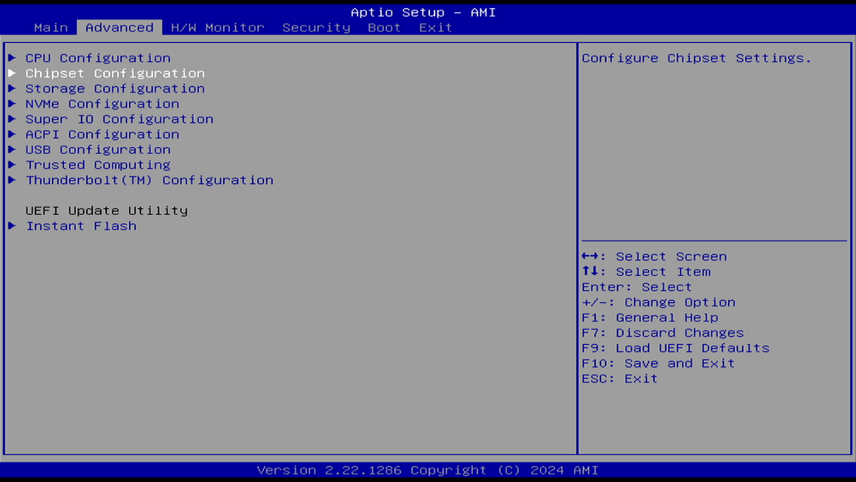
- Within the Advanced tab, open the Chipset Configuration screen
- Here we will set the machine to negotiate at Gen 3 speeds for stability.
- Please ensure the following settings are configured on no RAID systems:
  - PCIe Bandwidth Mode [x16]
  - PCIE1 Link Speed [GEN3]
  - PCIE2 Link Speed [GEN3]
  - PCIE3 Link Speed [GEN3]
  - PCIE4 Link Speed [GEN3]
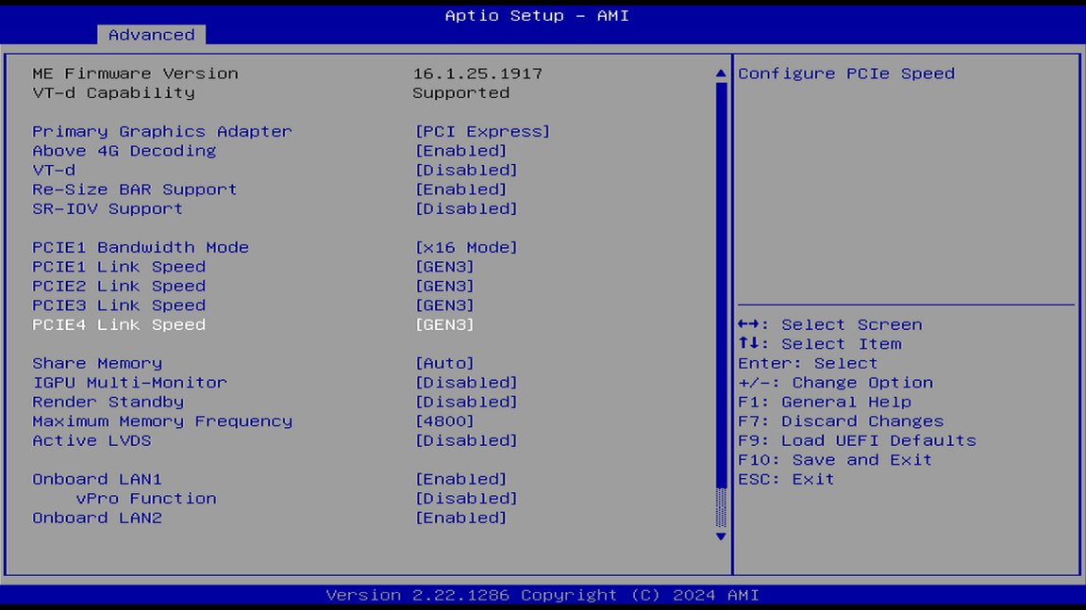
- After the PCIe link speeds are set, use your ESC key to back out of these screens and return you to the Advanced main tab. Next we will move to the Boot tab to configure the system to boot from the OS USB.
Note: BIOS screens and navigation paths may vary depending on the system. Use the arrow keys to navigate to the Boot tab. The objective is to configure the boot drive to the bootable USB that was previously created and mounted for loading the operating system (OS).
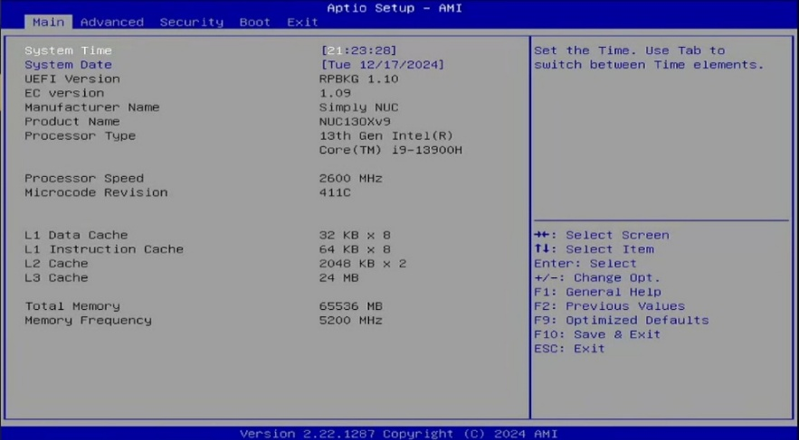
- Use the arrow keys to navigate through main menu and select the BOOT tab.
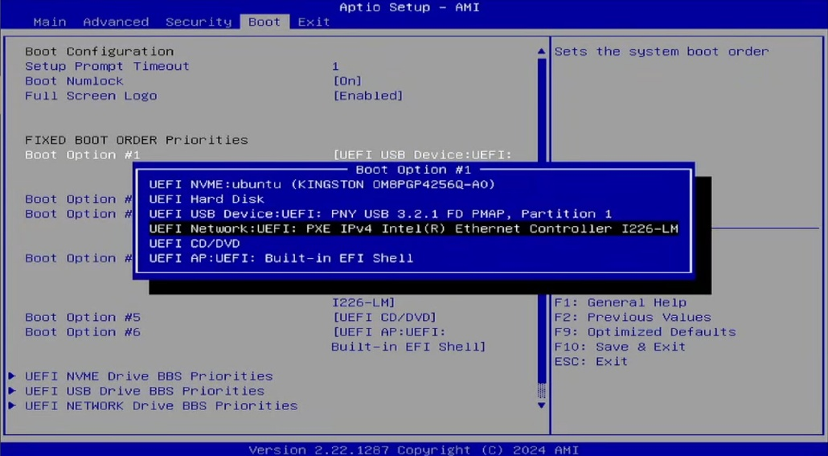

- Make sure that the USB drive is securely connected to a USB port.
- Identify the USB drive in the list of boot options and select it as Boot Option #1.
- Press “F10” to save the configuration and boot into that drive.
Note: If any prompts ask you to confirm, press Enter or select Yes to confirm saving changes.
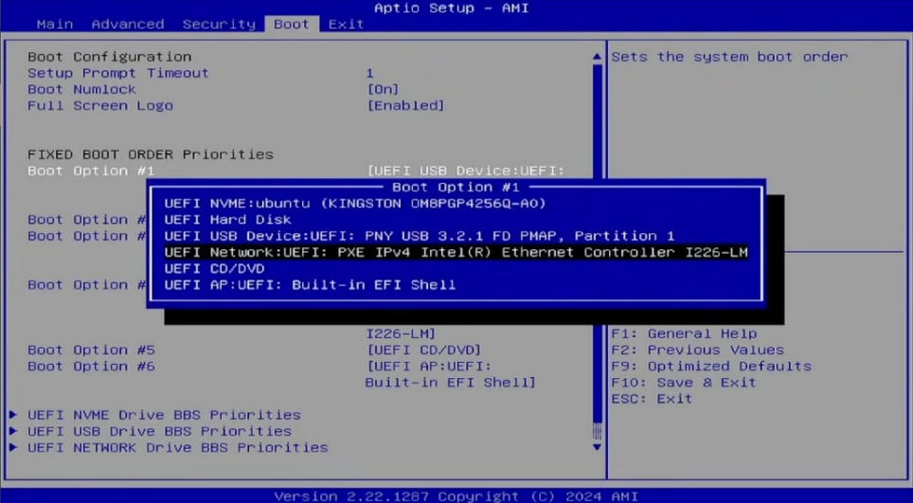

- System starts from the bootable USB drive and executes the OS installation prompts.

- Use the arrow keys to select “* Try or Install Ubuntu Server” and press Enter to install. It starts the Ubuntu configuration setup process. Wait for a moment.
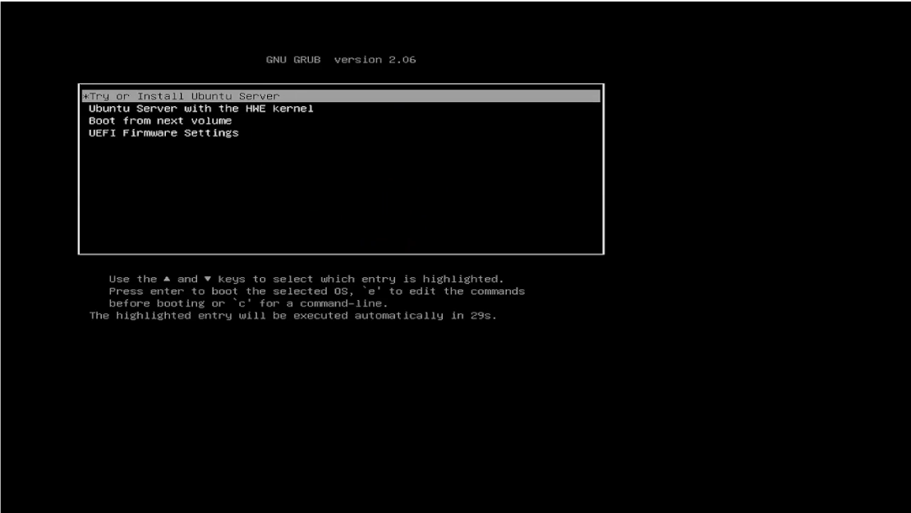

Optional: Bypass NVIDIA Display Issues (If Installer Hangs or Shows a Black Screen)
On some systems with NVIDIA GPUs, the installer may hang or display a black screen due to graphics driver initialization. If this occurs, use the steps below to temporarily disable graphics acceleration during installation.

- With “Try or Install Ubuntu Server” highlighted, press e to edit the boot parameters.
- Locate the line that begins with linux and ends with quiet ---.
- Using the arrow keys, move the cursor to the end of that line.
- Add a space, then type: nomodeset
- Press Ctrl + X or F10 to boot using the modified parameters.
This change is temporary and only affects the installer boot. NVIDIA drivers will be installed later during the provisioning process.

- The following instruction set is focused on Non-RAID systems. For ZFS RAID guidance, see OpenZFSforNexaiQ.docx and NexaiQ_ZFS_RAID_REQ2025.docx

- Use the arrow keys to select “English” from the language selection screen and press Enter to go to the next screen.
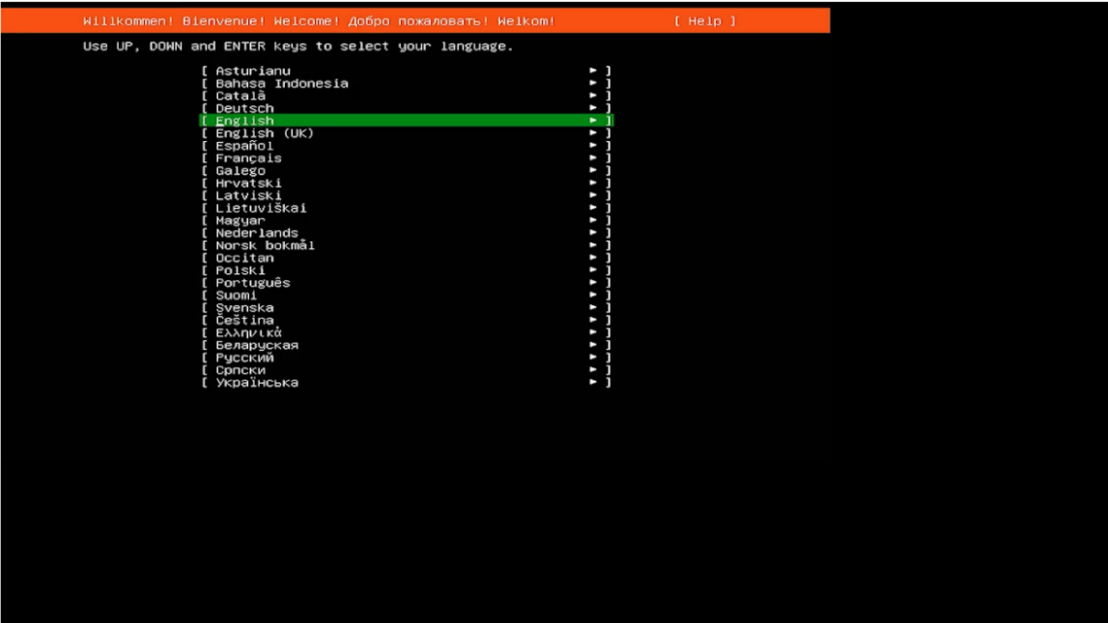

- A prompt will appear for the installer if a newer version exists.
- Use the arrow keys to select “Update to the new installer” and press Enter to go to the next screen.
Note: Always update to the latest installer when prompted during the OS installation process. This step is required to ensure the system benefits from critical updates, including improved hardware compatibility, enhanced security patches, and resolved installation issues. Proceeding without updating the installer may result in avoidable errors, reduced stability, or hardware incompatibilities. For optimal performance and reliability, updating the installer is mandatory before continuing with the setup.

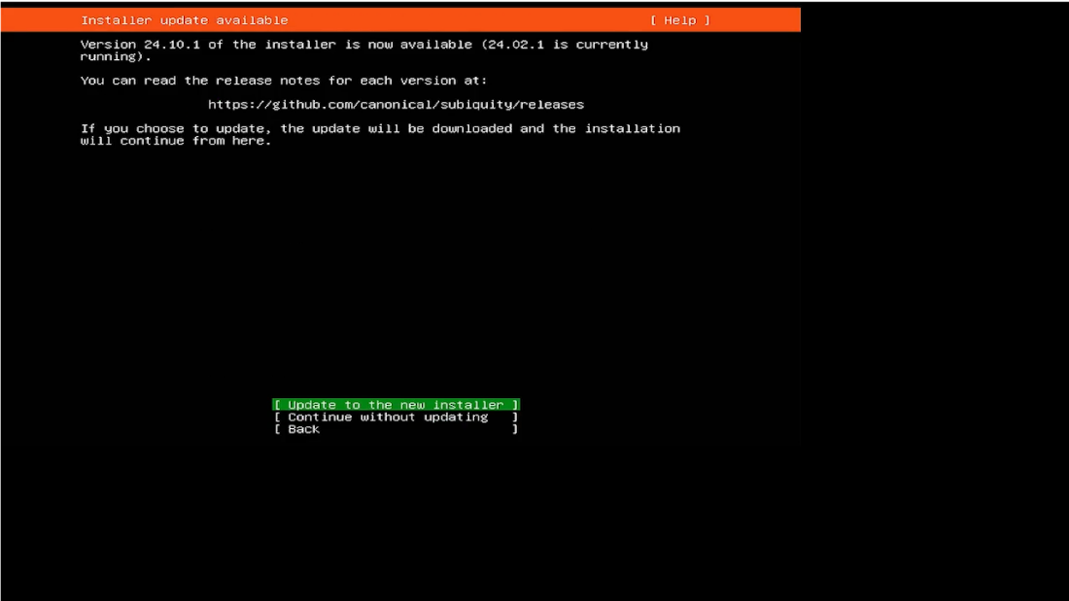

- Wait for a moment. The updated installer version will be downloaded.
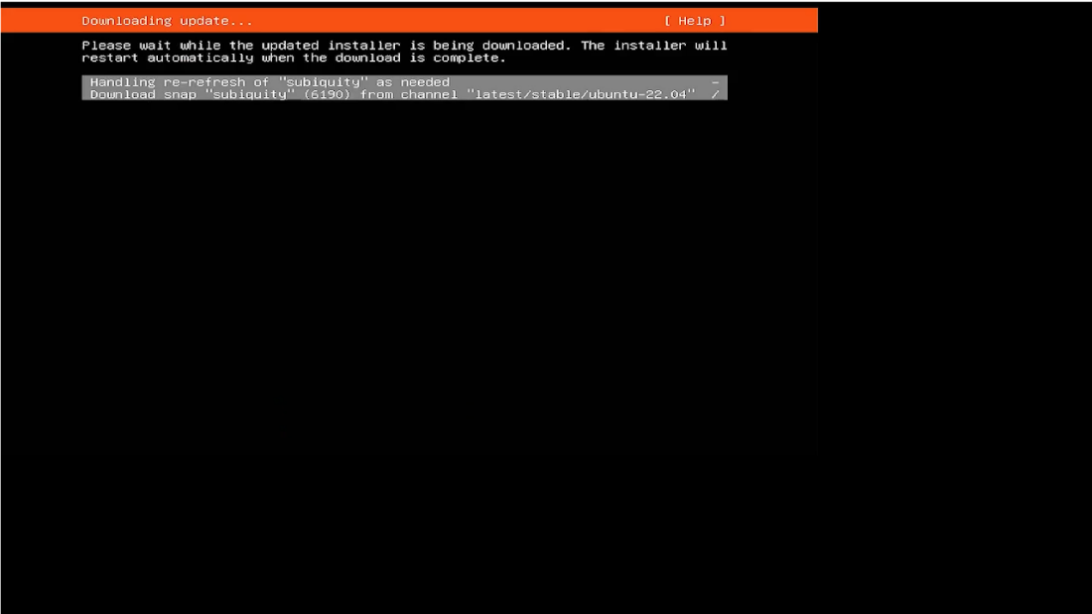
- On the Keyboard Configuration screen, open the dropdown menu and use the arrow keys to select “English (US)” for both Layout and Variant. Select Done and press Enter to go to the next screen.
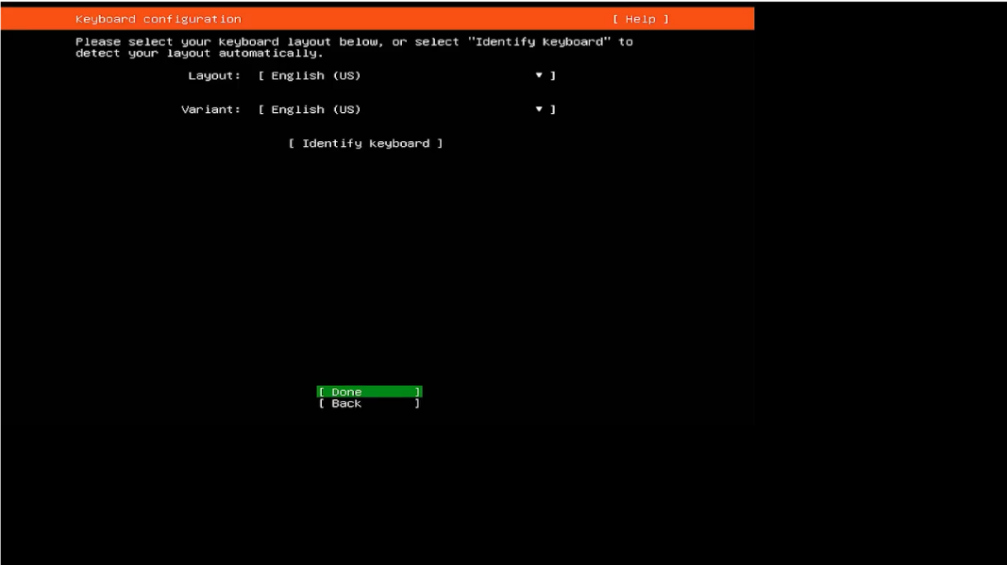

- On the Choose the type of installation screen, use Spacebar on the keyboard to select “Ubuntu Server”. Select Done and press Enter to go to the next screen.
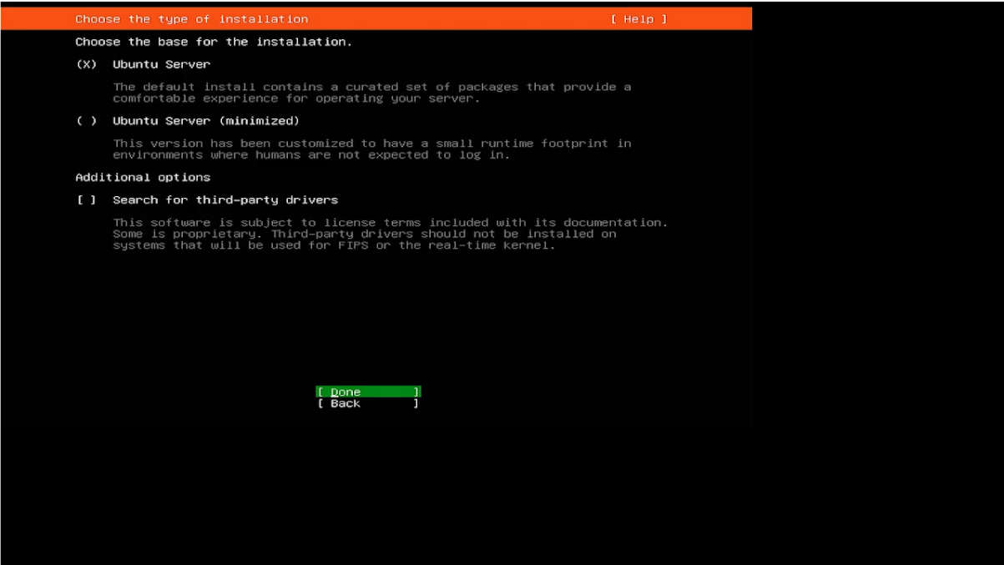
- Do not change any settings on the Network Configuration screen. Select Done and press Enter to go to the next screen.
Note: Leave DHCP no static IP is available.
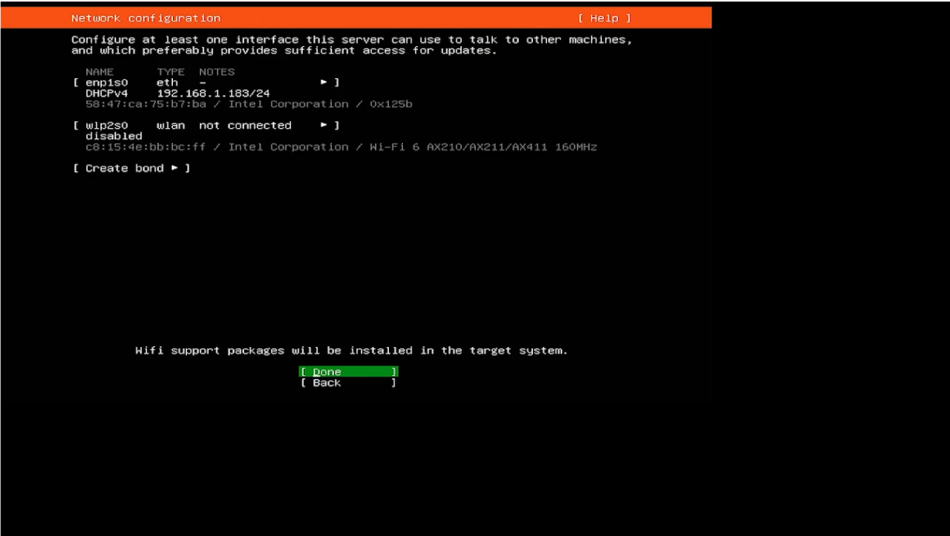

- Do not change any settings on the Proxy Configuration screen. Select Done and press Enter to go to the next screen.
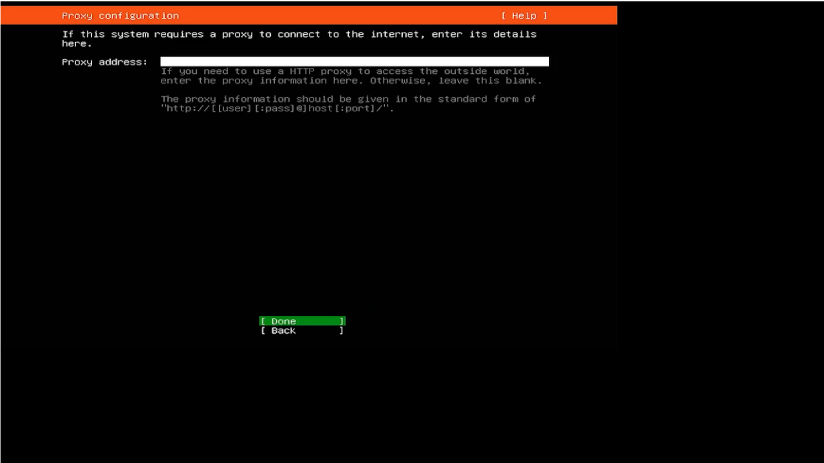

- Allow a moment for the mirror configuration to complete its test on the Ubuntu Archive Mirror Configuration screen. Select Done and press Enter to go to the next screen.
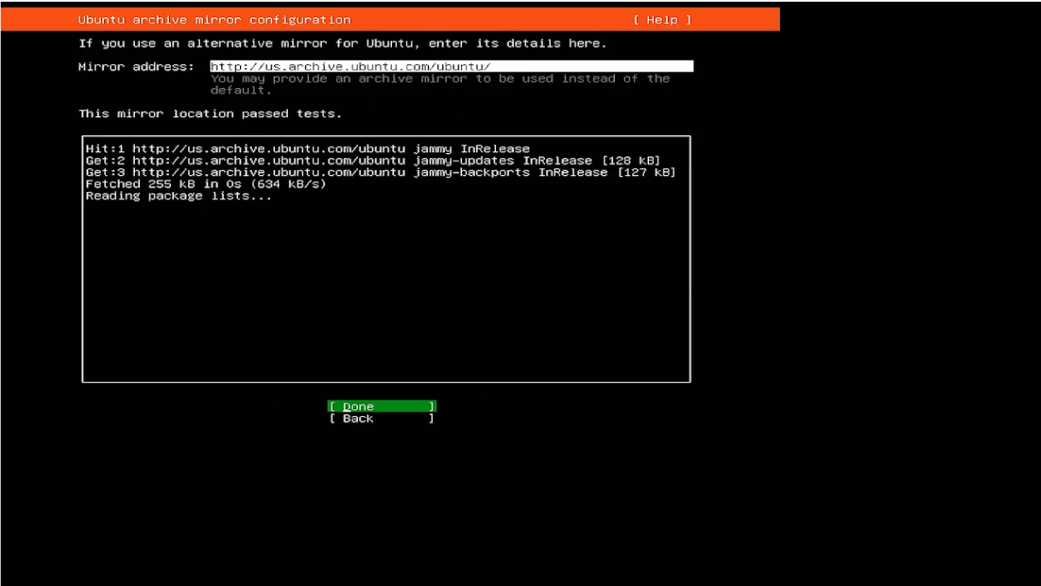

- On the Guided storage configuration screen, use Spacebar on the keyboard to select “Custom storage layout”. Select Done and press Enter to go to the next screen.
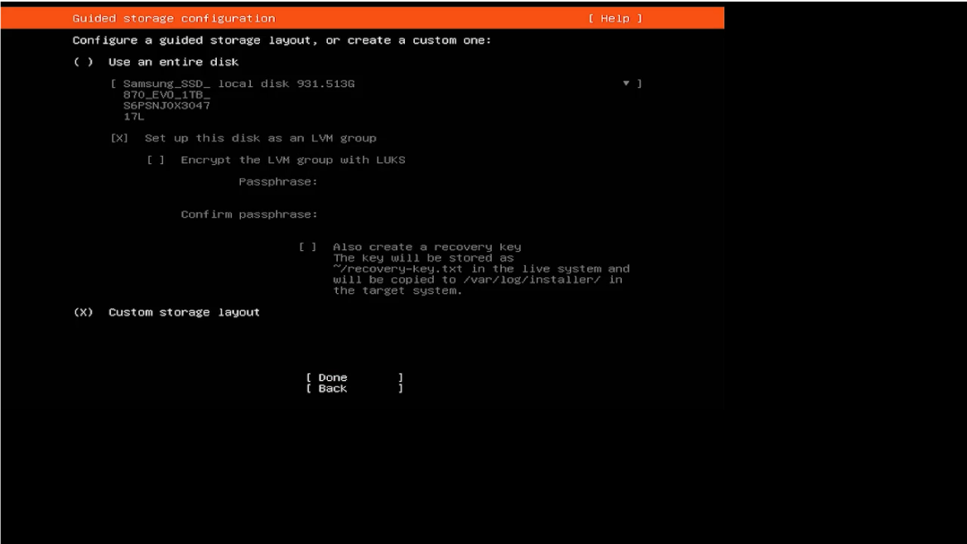
- On the Storage configuration screen, you can set up the partition and allocate space for the operating system, database, and video storage.
- Storage is where configurations will take place as we partition the discs.

NVMe SSD (OS/DB): Soterix will use 512GB NVMe SSD drives on Non-RAID systems and dual 1TB NVMe drives in RAID 1 for all RAID systems. Capacities to be allocated are defined below in the Non-RAID and RAID based systems.
Non-RAID (NR) Systems
NR systems use a single 512GB NVMe device for OS and application data.
Device | Mount Point | Size | Purpose
NVMe (512GB) | / | 220GB | Operating system and core services
1x 512GB  Non-RAID | /media/dbdata | 250GB | NexaiQ databases, metadata, and application data
 | Unallocated | ~5GB | Reserved (no use)
- /media/dbdata isolates the database and application I/O from the OS.
- No SLOG is used in NR systems.
RAID-Based Systems (Z1 / Z2 / Z3)
RAID systems use two 1TB NVMe devices in a mirrored (RAID-1) configuration for OS and application data.
Device | Mount Point | Size | Purpose
NVMe (1TB) | / | 400GB | Operating system and core services
2x 1TB  RAID-1 | /media/dbdata | 450GB | NexaiQ databases, metadata, and application data
 | SLOG | ~80GB | Reserved exclusively for SLOG provisioning
- OS and database partitions are mirrored for resilience.
- The remaining NVMe space is reserved and must not be formatted.
- This space is later carved for ZFS SLOG per channel tier and RAID requirements.
- No other use of the reserved NVMe space is permitted.

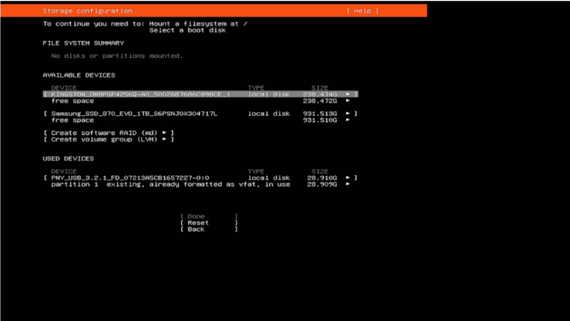

- OS (/) and DB (/dbdata) Storage (NVMe SSD)
- From the unformatted and unmounted “free space,” select “Add GPT Partition.” Allocate GB to configure the Operating System (OS) on the available NVMe SSD.
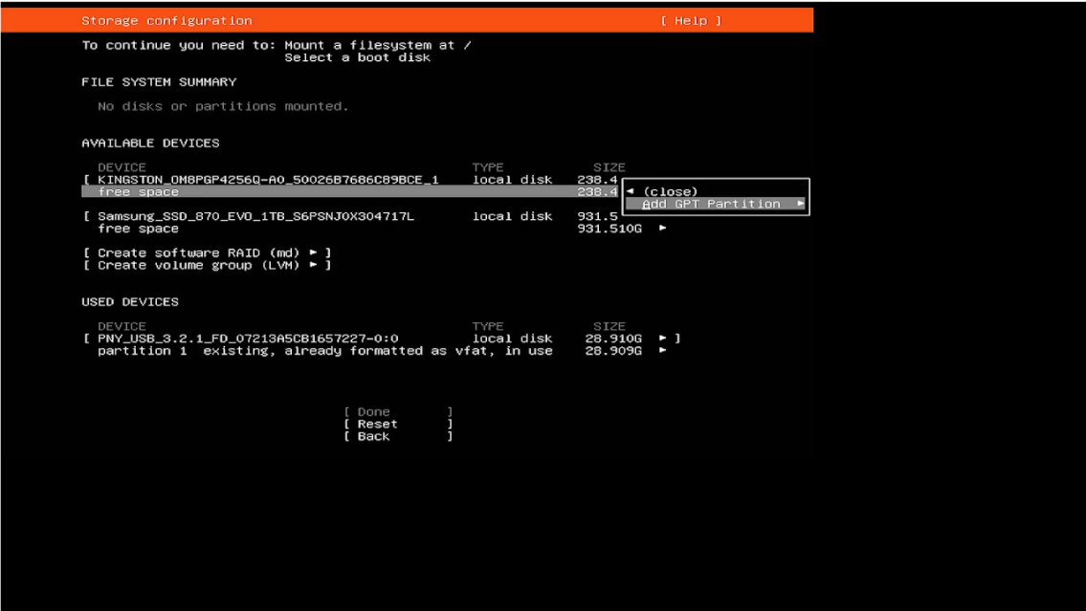

- Fill in the Size column and keep the rest of the format as default.
- Select “Create” and press Enter to create the partition.
Note: If you select “Cancel” and push Enter, it will return you to the previous screen.
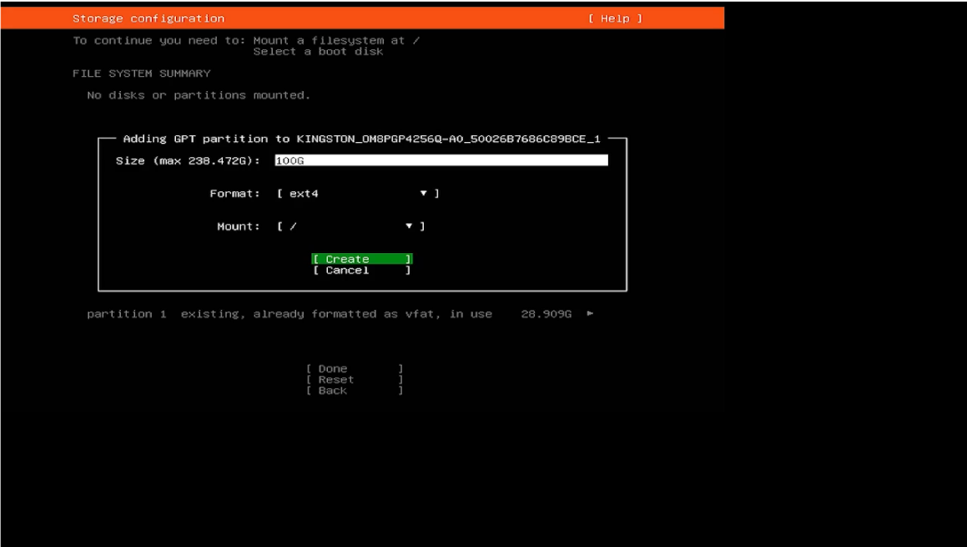

- A partition will be created and appear at the top of the "Mount" screen.
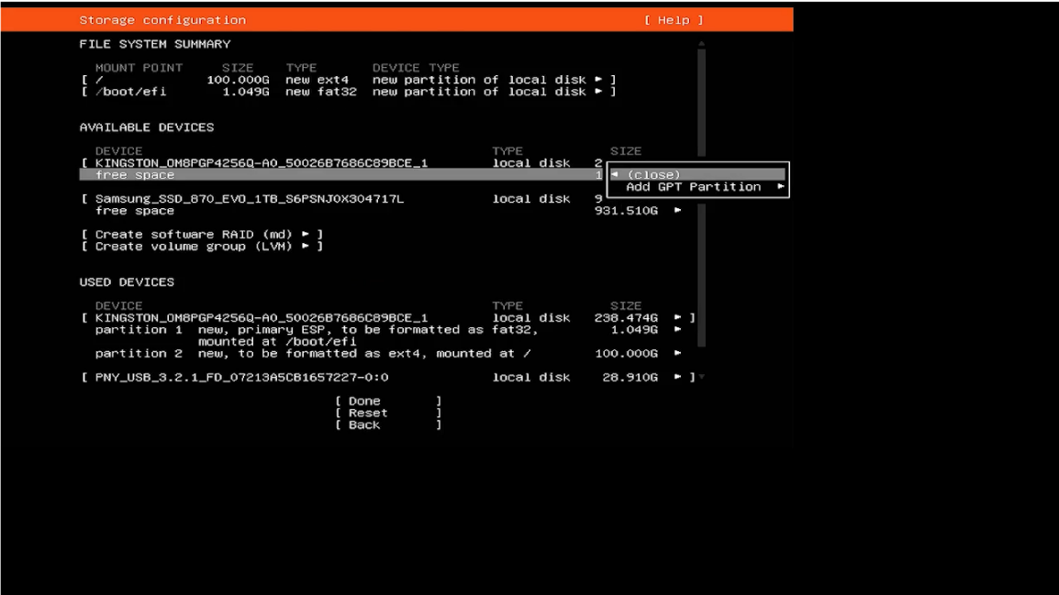

- Do the steps again to allocate space for the partition on the NVMe SSD.
- From “free space,” select ‘Add GPT Partition’.
- The size column is left blank (It will take the remaining unallocated space).
- Format should be selected as “ext4.”
- From the Mount dropdown, choose "other" and give it a new name, “media/dbdata.”
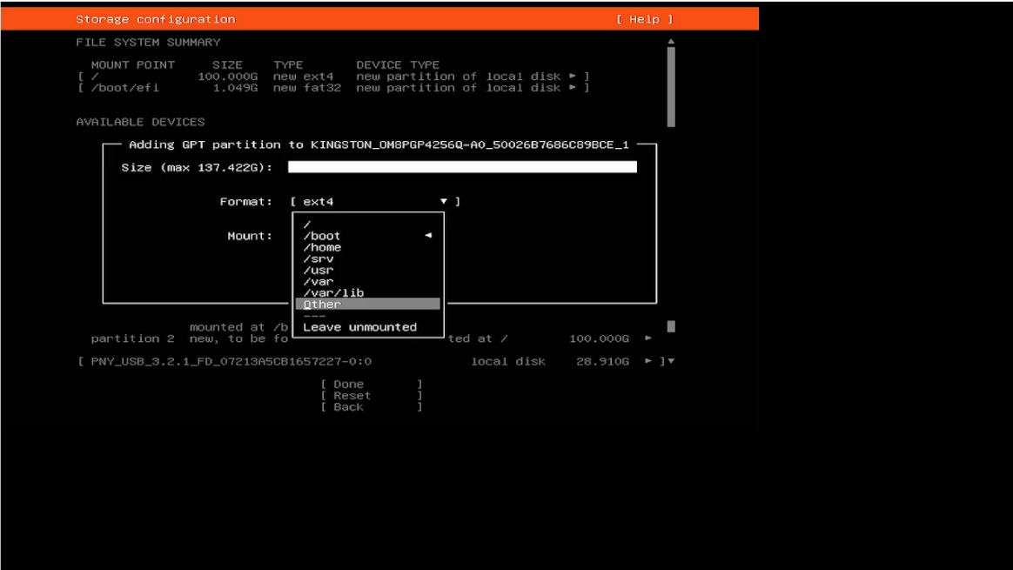

- Choose “Create” and press Enter to set up the partition.
Note: Selecting “Cancel” and pressing Enter will return you to the previous screen.
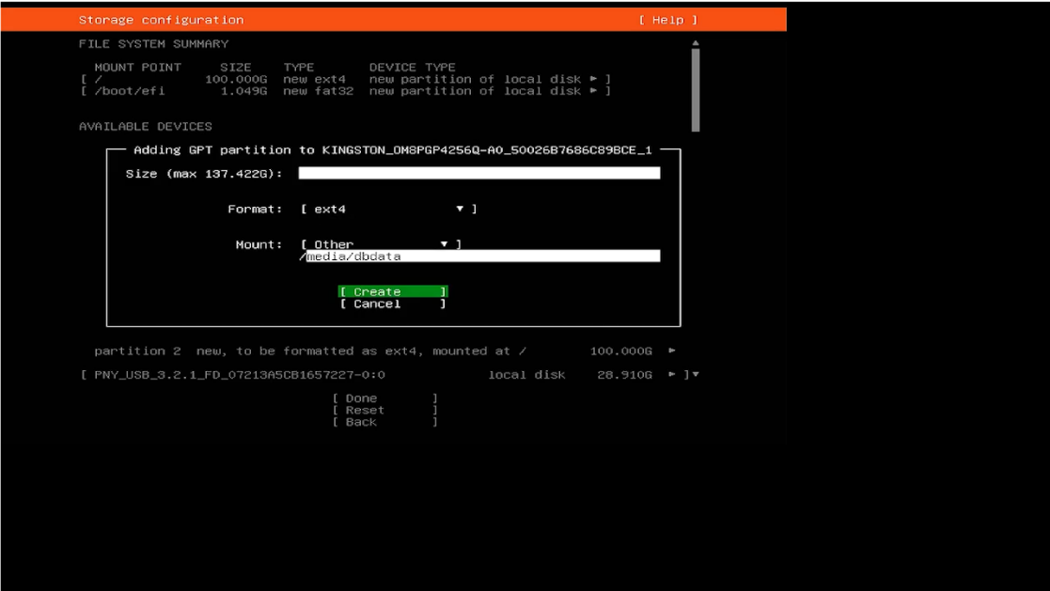
- A partition will be created and appears at the top of the "Mount" screen.
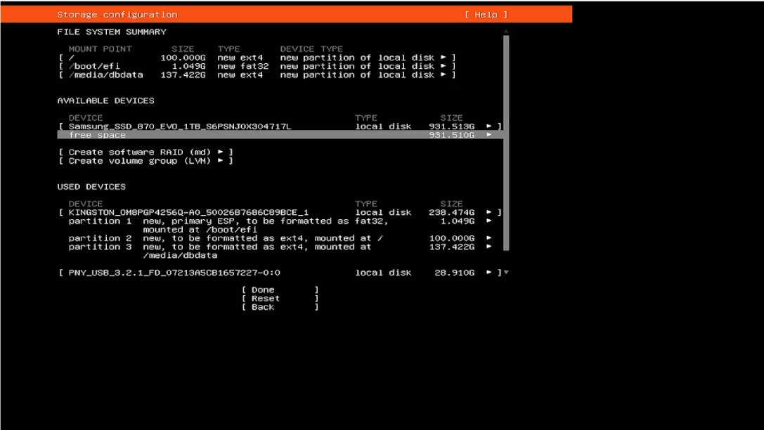

- Video Data (/media/vdata) Storage (HDD)
The drive's available capacity will be allocated to "media/vdata.”

Non-RAID vs RAID: This is where we bifurcate the instructions. For Non-RAID systems, continue forward. For setting up ZFS RAID, refer to the ZFS RAID section directly after this one.

- From the unformatted and unmounted “free space,” select “Add GPT Partition”.
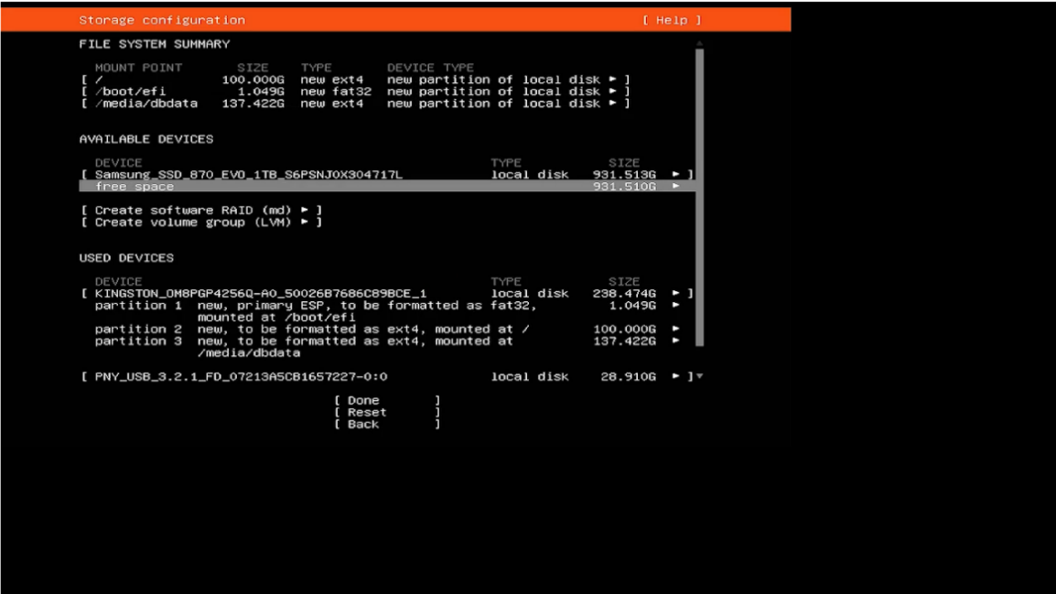

- Size column left blank (It will take all unallocated space).
- Format should be selected as “ext4.”
- From the Mount dropdown, select "other" and give it a new name, “media/vdata.”
- Use the arrow keys to select “Create” and press Enter to set up the partition.
Note: If you select “Cancel” and press Enter, it will return you to the previous screen.
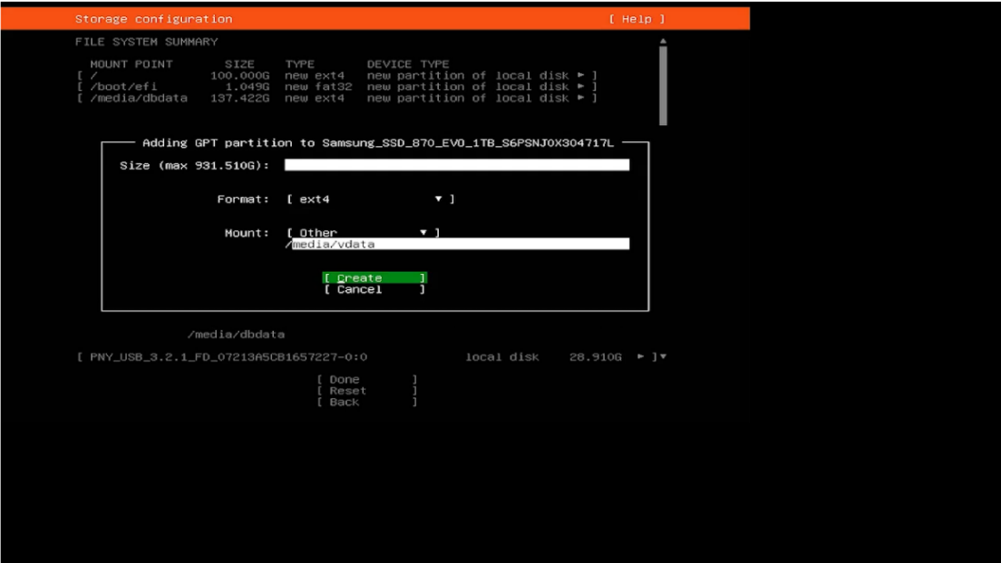
‘
- When you have completed the allocations, validate that the following directories and size allocations will be created:
- PARTITION | - SPACE ALLOCATIONS
- / | - As defined above
- /media/dbdata | - Remaining NVMe space
- /media/vdata | - Total HDD Non-RAID storage (JBOD)
NOTE: These directories must be present when executing the gold image. It will look for them as it installs.
- Once the partition allocations are verified, scroll down the page and select “Done.”
Note: If you select Reset and press Enter, the entire process will restart from the beginning. If you select Back and press Enter, you will return to the previous screen.
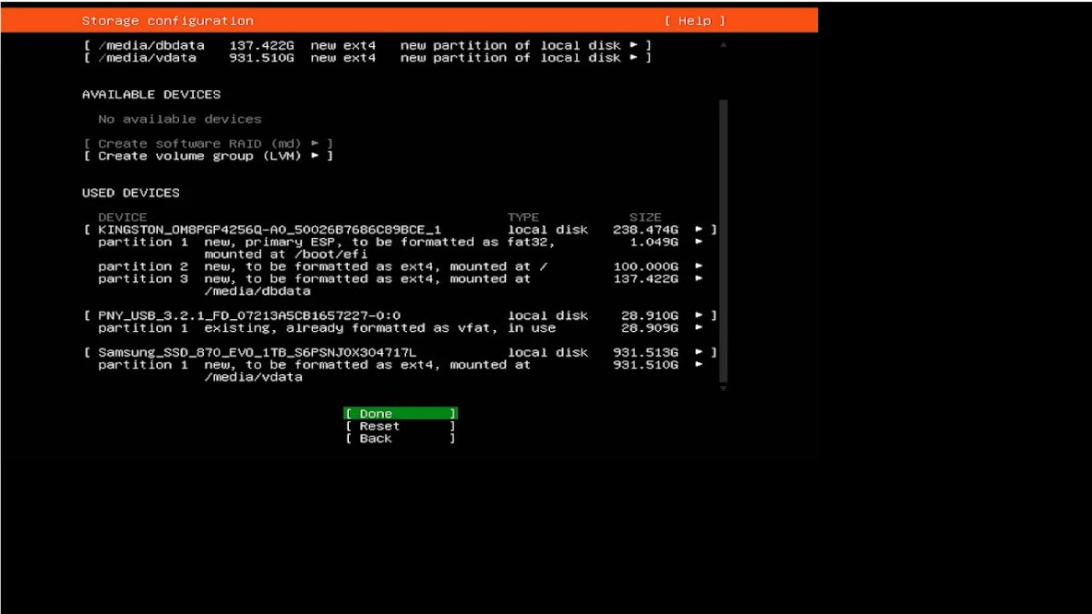

ZFS RAID (HDD Configuration)
During the Ubuntu OS installation, do not mount, format, or assign any HDDs intended for ZFS to the operating system. These drives must remain unconfigured and unmounted throughout the OS install process.

ZFS requires OpenZFS to be installed after the operating system is fully installed. Once OpenZFS is in place, the HDDs will be formatted, pooled, and mounted using standard OpenZFS workflows to create the ZFS RAID array.

Important: Any HDDs used for ZFS must not be added to /media/vdata or assigned a filesystem during OS installation. Doing so will prevent the proper creation of a ZFS pool.

- Fill the following details on the “Profile configuration” screen.
- Your Name:
- Your Server Name:
- Pick a Username:
- Choose a Password:
- Confirm your password:

- Use the arrow keys to select “Done” to go to the next screen.
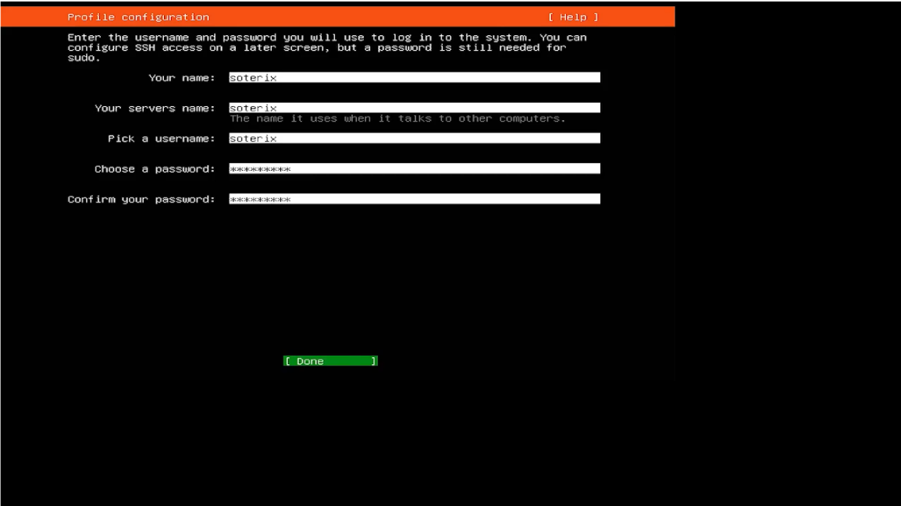

- On the Upgrade to Ubuntu Pro” screen, use the Spacebar on the keyboard to select “Skip for now.” Select Continue to go to the next screen.
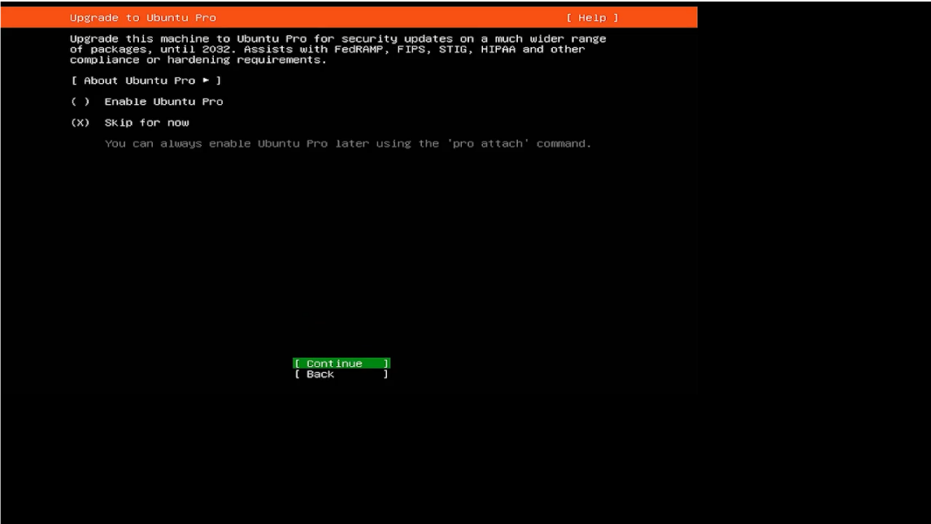

- On the SSH configuration screen, use the Spacebar on the keyboard to select “Install openSSH server.” Then, select “Done” to proceed to the next screen.
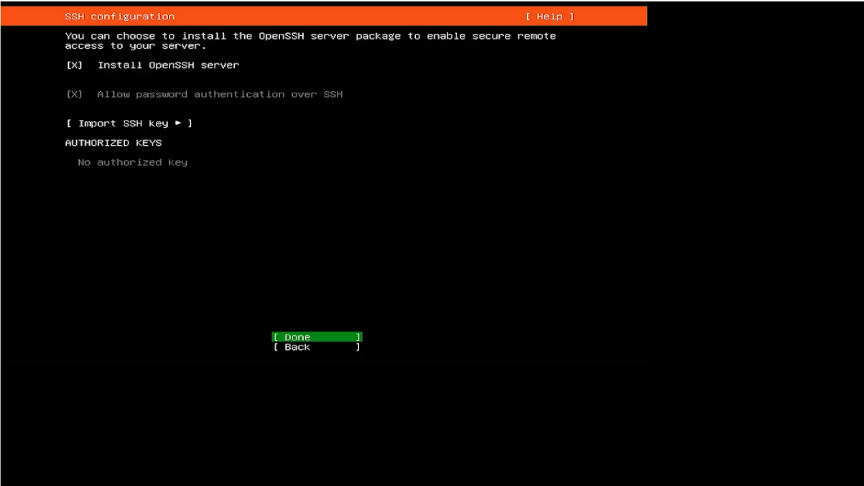

- On the Featured server snaps screen, ensure “Done” is highlighted and press Enter to go to the next screen.
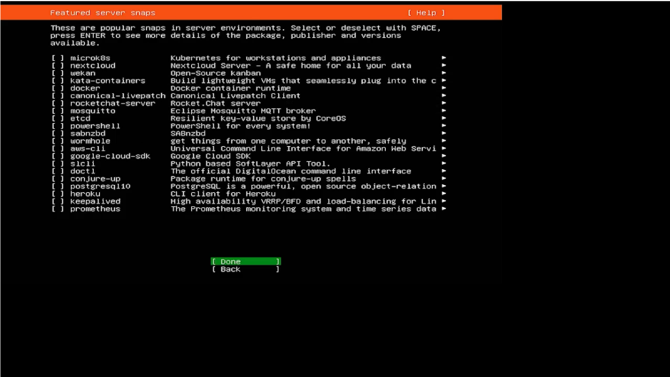

- The Operating System (OS) starts installing. Give it some time to finish.
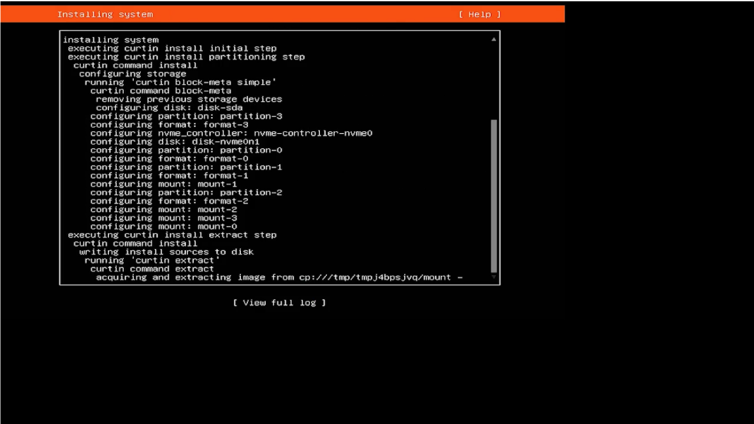

- After the installation is complete, a reboot option will appear on the screen. Highlight “Reboot Now” and press Enter to restart the system.
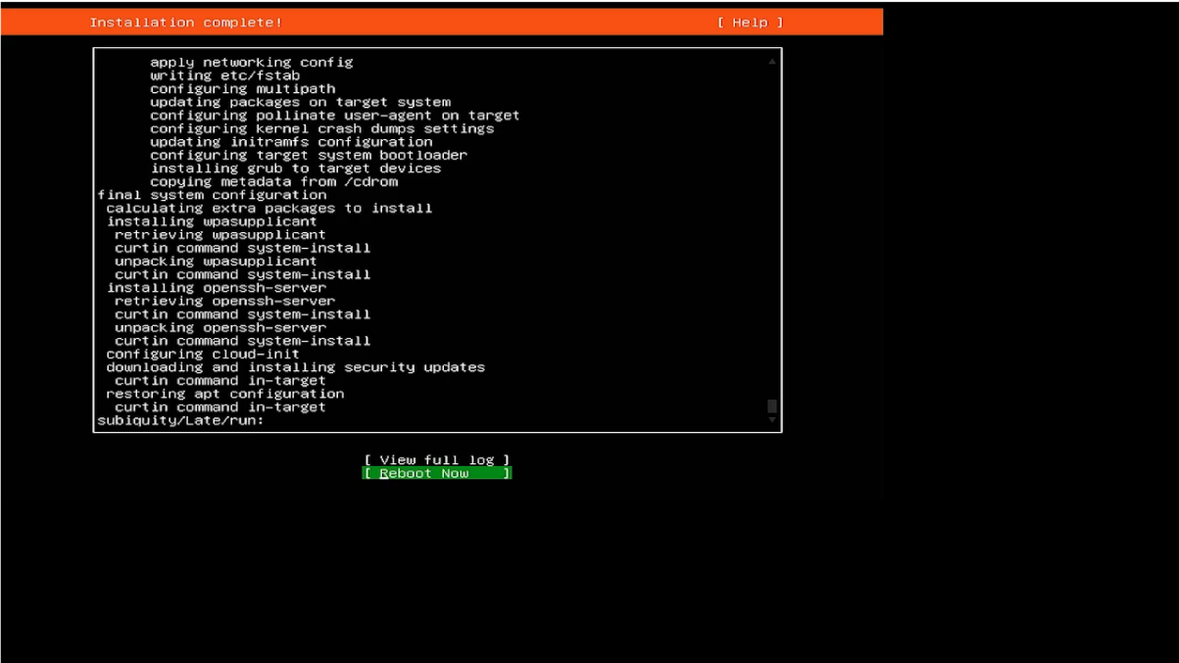

- Enter username and password to sign in the system.
- Username:
- Password:

- Enter the command below and wait for the updates and upgrades to be completed.
sudo apt update && sudo apt upgrade -y
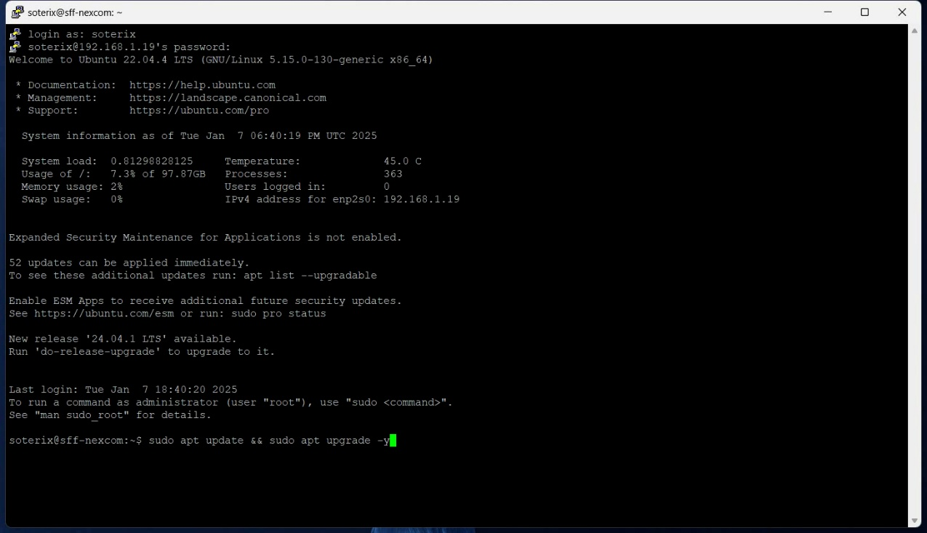

The system is ready to proceed once the updates and upgrades are complete.
Enter Password:

Note: Before taking further actions, ensure updates and upgrades are completed.

Select “<OK>” and press Enter or Spacebar to configure Package.
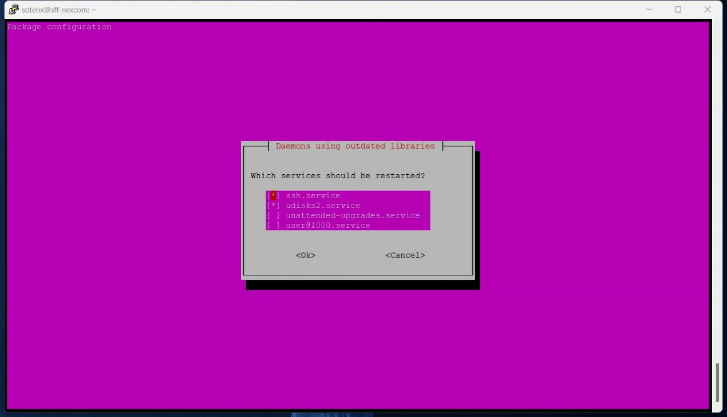

- Enter the command given below to clean the environment before loading the VSaaS image.
sudo apt autoremove -y && sudo apt autoclean
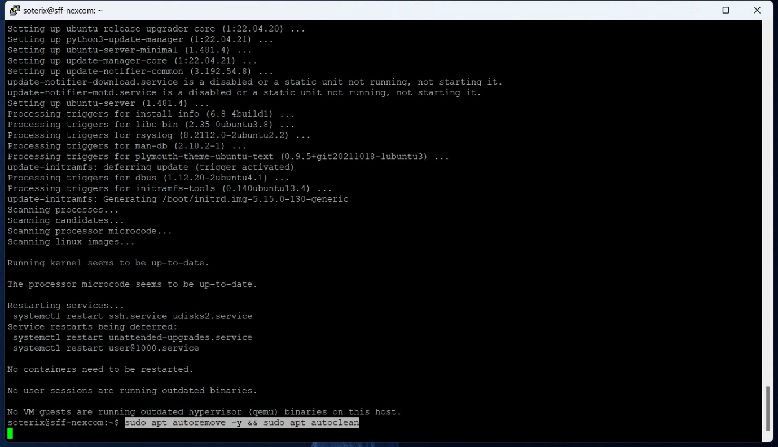

- Enter the command given below to make sure that the system has the necessary processes installed to download, unzip, and install the file.
sudo apt install -y wget curl tar
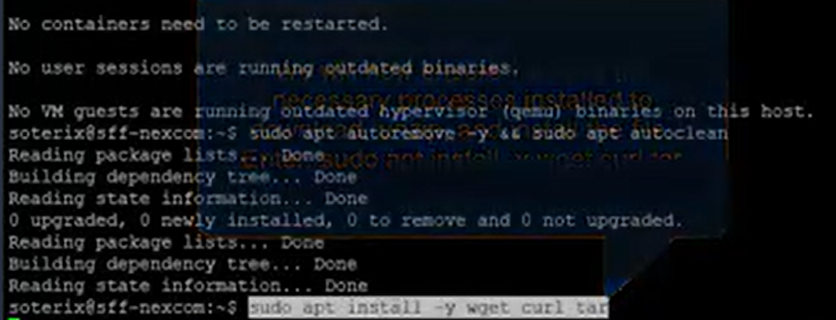

- The System is configured and ready to install the NexaiQ (image file). Unless, this is a OpenZFS RAID system, then we must move to the next stage and set up the ZFS RAID.

Install NexaiQ
This section walks through downloading and installing the NexaiQ Edge software package on the system. All commands should be executed from a terminal session with network connectivity confirmed.

Prerequisites
- Ubuntu OS installation completed
- System has internet access
- User has sudo privileges

Step 1: Download the NexaiQ Installation Package
Download the latest NexaiQ Edge installation package using the command below:
wget -v --no-check-certificate -O soterix_vsaas_edge_nvid.tar.gz \
https://applications.soterixcloud.com/vsaas/release/latest/nvidiagpu/soterix_vsaas_edge_nvid.tar.gz
This will retrieve the most current NVIDIA GPU–enabled NexaiQ Edge release and save it locally.

Step 2: Extract the Installation Package
Once the download is completed, extract the contents of the archive:
tar -zxvf soterix_vsaas_edge_nvid.tar.gz
This will create a directory containing the NexaiQ installation files.

Step 3: Run the NexaiQ Installation Script
Change into the extracted directory and execute the installation script:
cd soterix_vsaas_edge_nvid
sudo bash Install_VSaaS_Edge.sh
The installation script will:
- Install required system dependencies
- Configure Docker and supporting services
- Install NVIDIA drivers (if required)
- Deploy and configure NexaiQ Edge services
Follow any on-screen prompts and allow the script to complete without interruption.

Important Notes
- The system may reboot during or after installation, depending on driver and kernel updates.
- Do not manually stop services or modify configurations during installation.
- NexaiQ services will automatically start once installation is complete.

Completion Guidelines

Unique System ID
An essential step for the Original Equipment Manufacturer (OEM) is to identify the unique System ID generated by the NexaiQ software upon the completion of installation.
- Display of System ID: Once the NexaiQ software installation is complete, the unique System ID will be generated and displayed on the screen.
- Accurate Documentation: The OEM must accurately record the System ID, as it serves as a crucial identifier. This UUID should be documented and provided to Soterix Systems when sending the completion documentation for this order. This ID must also be converted to a QR code and used on the shipping label when the systems are shipped.
- Barcode Generation: Use the QR code generator and enter the system-generated serial number (32-character).
Note: The system-generated serial number (32 characters) is generated during the NexaiQ software installation. It is important to enter the correct and verified serial number when generating the system QR Code. If the serial number is incorrect, the server will not verify it, which may cause issues for the customer.
Note: Download and Print: After generating the QR Code, download it as an image. Print the barcode on the shipping labels or the product packaging.
Note: Make sure that the printed QR Code is clear and scannable. If not, generate a new barcode using the same System ID.
- Record: Record all generated QR Codes for tracking and future reference. Make sure each QR Code is linked to its respective product or shipment.

Quality Assurance Checklist
This checklist guarantees comprehensive quality assurance while creating a unique System ID and its corresponding barcode in NexaiQ software, promoting precise documentation and streamlined shipping practices.
Checklist | Yes | No
Does the system include the required SKU components on the filled PO?
Does it have the correct size and quantity of NVMe and HDDs?
Does it have the appropriate system RAM?
Does it have the correct GPU, if applicable?
Does it have the right processor?
Is Ubuntu 22.04 LTS Server installed?
Did the installation complete successfully?

Shipping Instructions

Labelling Requirements
When preparing the system for shipping, adhere to the labelling requirements. Proper labelling helps prevent damage and ensures that the system is handled correctly.

General Requirements |  | Specific Requirements
Label Material | Moisture and tearing-resistant | Sender Info. | Clearly visible  - Sender’s name  - Address, and contact details  - Date
Language | English (change as per customer requirements) | Recipient Info. | Clearly visible  - Recipient’s name  - Address, and contact details
Visibility | Good | Package details | Document details with:  - Tracking #
Positioning | Top or side | Compliance Markings | Include necessary local or international shipping regulations
Tracking Details | Shipping tracking details | Handling Instructions | Use cautionary instructions:  - Fragile  - This Side Up  - Handle with Care

The label that the OEM will create will contain:
- Ship To Address
- PO ID
- NIC Mac Address/s
- System ID QR Code
- System ID printed below the QR code in readable text

Packing for Transit
To ensure the safe delivery of our items, adhere to the following requirements:
- Make sure the packaging is safe and secure.
- Attach "FRAGILE" and "HANDLE WITH CARE" stickers on all sides of the boxes.
- If there's a preferred orientation for the boxes, place "THIS SIDE UP" labels in the correct spots on the box.
These steps are crucial to prevent damage during transit. Thank you for your attention to these details!

